Report of | Meeting | Date
Deputy Chief Executive  (Introduced by Leader of the Council and Cabinet Member (Strategy and Reform)) | Council | Wednesday, 24 November 2021
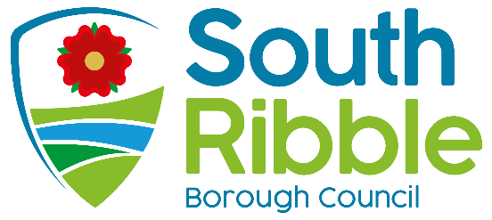

Is this report confidential? | No

Is this decision key? | Not applicable

Changes to Council Appointments

Purpose of the Report
- To seek the Council’s approval for changes to appointments to South Ribble Partnership following its amalgamation with Chorley Public Service Reform Board.

Recommendations to Council
- That the Leader of the Council is appointed to Chorley and South Ribble Partnership Executive.

Reasons for recommendations
- The recent development of a joint Chorley and South Ribble Partnership has resulted in the need to update the appointment of the Council’s representative to the new partnership structure

Other options considered and rejected
- No other options have been considered as the appointment of the Leader is to continue the existing practise of the key partnership body including the Leader of the Council as part of the Partnership’s role to lead in key strategic decisions and priorities with partner organisations.

Corporate priorities
- The report relates to the following corporate priorities: (please bold all those applicable):

An exemplary council | Thriving communities
A fair local economy that works for everyone | Good homes, green spaces, healthy places

Background to the report
- At the Annual Council meeting on Wednesday, 19 May 2021 the appointments to committees were agreed.

- This report outlines the new structure of Chorley and South Ribble Partnership which replaces the previous South Ribble Partnership to which the Leader of the Council was appointed.

Chorley and South Ribble Partnership
- As part of the delivery of the Corporate Strategy for 2020/21, the existing South Ribble Partnership and Chorley Public Service Reform Board came together to consider whether there was opportunity to develop as a joint partnership to cover both districts,

- In September 2021, the Chorley and South Ribble Partnership was established with a new governance structure.

- The governance structure sets out an executive board which will be chaired on rotation by the Leader of each Council. The Partnership determined that in 2021 to September 2022 it would be chaired by South Ribble.

- Due to the nature of the partnership and its role to work with partners on key strategic issues around the delivery of local services and economy, it is recommended that the Leader is appointed to take up the position as Chair for the next 12 months and following that vice chair of the Partnership.

Climate change and air quality
- The work noted in this report does not impact the climate change and sustainability targets of the Council’s Green Agenda and all environmental considerations are in place.

Equality and diversity
- None as a result of this report.

Risk

None as a result of this report.

Comments of the Statutory Finance Officer
- There are no financial implications.

Comments of the Monitoring Officer
- There are no concerns from a legal perspective. It is for Full Council to make this decision. The Leader being on the Partnership Board is existing practice. The change is that there is now a joint Chorley and South Ribble Partnership.

Background documents
There are no background papers to this report

Appendices
There are no appendices to this report
Report Author: | Email: | Telephone: | Date:
Howard Anthony  Performance and Partnerships Team Leader | howard.anthony@southribble.gov.uk | 01772 62xxxx | 28/10/2021

